CGRA 151, T2 2016, Assignment 5 Plan

Student name: Matthew Schmidt

Student ID: 300235737

Name of game/artwork: Asteroid

Vision

1. Game concept: You fly your ship through asteroid fields and destroy the asteroids while trying to avoid them killing you by crashing into you. You get a score on the size of the asteroids you destroy.
2. Game play: um the arrow keys will control your ship you turn left with left you turn right with right and you increase the speed with up and decrease with down. There will be a momentum system of a kind. Then you can shoot your main gun with ‘s’ and pick up bonus that use ‘w’, ’f’, ’a’ these will be defined by the bonus you pick up.
3. Visual design: Black screen with white ship but the asteroids will be different colours for the fun of it. As the original asteroid was a black and white game I don’t feel that I have to get crazy with the colours.

Original. Concept.

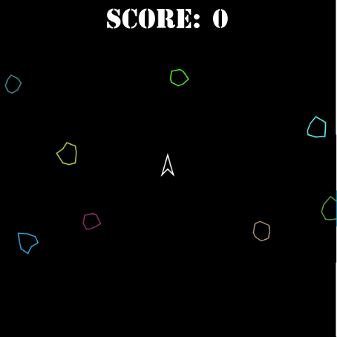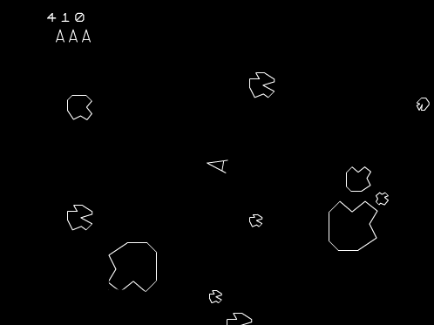

Timetable

1. A core working program (done by 27 September): You will be able to fly around shot asteroids have your score increase and one pick up. There will be a leveling system as it the asteroids will get bigger every turn and there will be more of them.
2. A reasonable submission (by 4 October): [more pickups will be done and I will endeavor to find any bugs and start working on the layout so the HUD feels nice and any other things that just feel wrong. Will also start trying to implement a story line to the game as I have one in my head.
3. A well-polished submission (by 11 October): story line and a well-polished bice looking game should be done. The game should be running at full screen. I have no idea of what I will get done by know because most likely I will have been completed by this time.